Our task is to assemble the following structure, which includes a support cross and upper and lower servo supports. For assembly, we need 4 screws and 4 nuts.

We begin assembling the robot shoulders inserting M2 size nuts into the grooves of the support cross. The nut is inserted as follows (otherwise, the nut may get stuck).

When inserting, it is important to align the nut with the screw hole. It the nut does not reach the desired position, you can carefully push it in with a flat screwdriver or another handy tool.

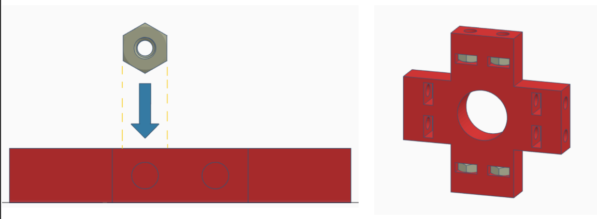

Then, we thread the screws (size M2 x 10) into the holes of the servo supports and insert the screws into the support cross, sewing them into the nuts.

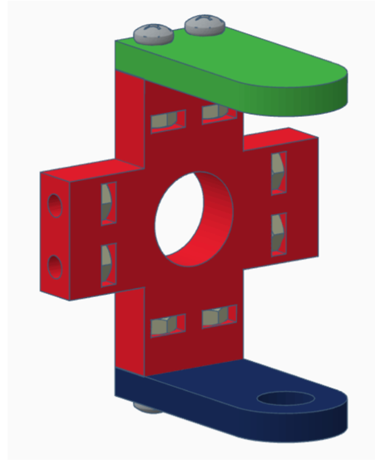

Similarly, we assemble the second pair of shoulder, also mirrored.

This step involves connecting the expansion board and the DC-Dc buck converter. This connection is performed using soldering and can be done either before or after the assembly is completed. It is necessary to connect the output contacts of the converter (VOUT and GND) to the corresponding contacts on the expansion board (5V and GND). Due to the robot’s design, standard „male-female” connector cables are not recommended, as they may burn out from the 1A current in the circuit.

At this point, we finish assembling the robot’s shoulders. We check whether all the printed shoulders parts are connected in the correct order. Remember, we should have two pairs of mirror support elements.

Attach the remaining structural element. To secure them, you also need 4 screws and 4 nuts (the dimensions are the same - M2 x 10 and M2, respectively). Insert the nuts in the same way into the remaining grooves of the support cross.

Next, assemble the second shoulder, pay attention to ensure you get two mirrors shoulder; the upper and lower servo supports, which are attached to the sides of the support cross, must „swap places” on the second shoulder.

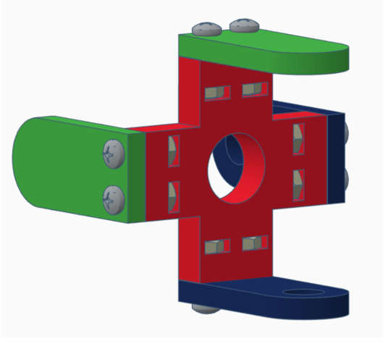

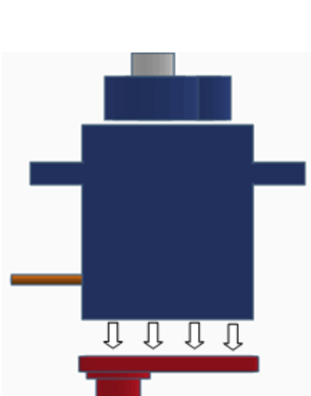

Using double-sided tape, attach the servo support to the servo casting. All eight servos must have a support. Ensure the cylindrical part of the support is located on the servo shaft side. If all the plastic parts are ready, proceed to servo calibration. All servos must be set to 90 degrees; this position will be the robot’s start or zero point. When all the servos are set to 90 degrees, the spider stands right. You can set all the servos to 90 degrees with a special device, such as a servo tester, or by programming.

When connecting the servo to the expansion board, it is necessary to check the correct connection of the contact (red wire - 5V power pin/simply V; brown wire - GND ground pin/simply G; orange wire - S signal wire/connected to Arduino digital pin).if we have doubts about servo functioning, check with a physical servo switch from one pin to another.

The tested and calibrated servos should be disconnected after connecting it and put aside. The calibrated servos are then mounted into the shoulders of the robots. The plastic is quite flexible and usually bends slightly without breaking. If the servo is not fitting properly, the screws should be loosened by 1-2 mm, and after the servo installed, they should be tightened again. Check the possibility of turning the cylindrical part of the servo support into the groove of the lower support, as these parts can be difficult to connect after shrinkage of the printed parts. If this turn is difficult, place the part together and rotate the connection several times to loosen it a bit. Fixing the servo horn in the top servo support can be challenging, due to imprecise modeling. In this case, you can use pliers to gently push the servo pump into the groove.

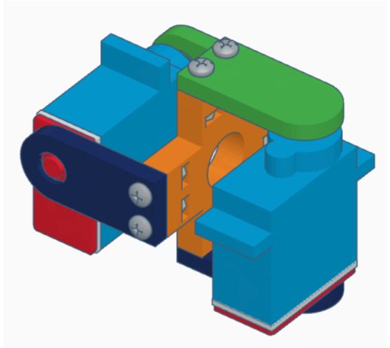

Drilling holes for the battery pack is inappropriate, as the different compartments have varying dimensions and varying location of fastening holes. The battery pack is held on the lower surface of the case by limiting borders. If necessary, the battery compartment cab be secured with double-sided tape.

The first step is installing the racks for mounting the upper plate of the case. Use M3x6 screws for this installation. When fixing the racks on the plastic side, it is necessary to place a washer M3 size.

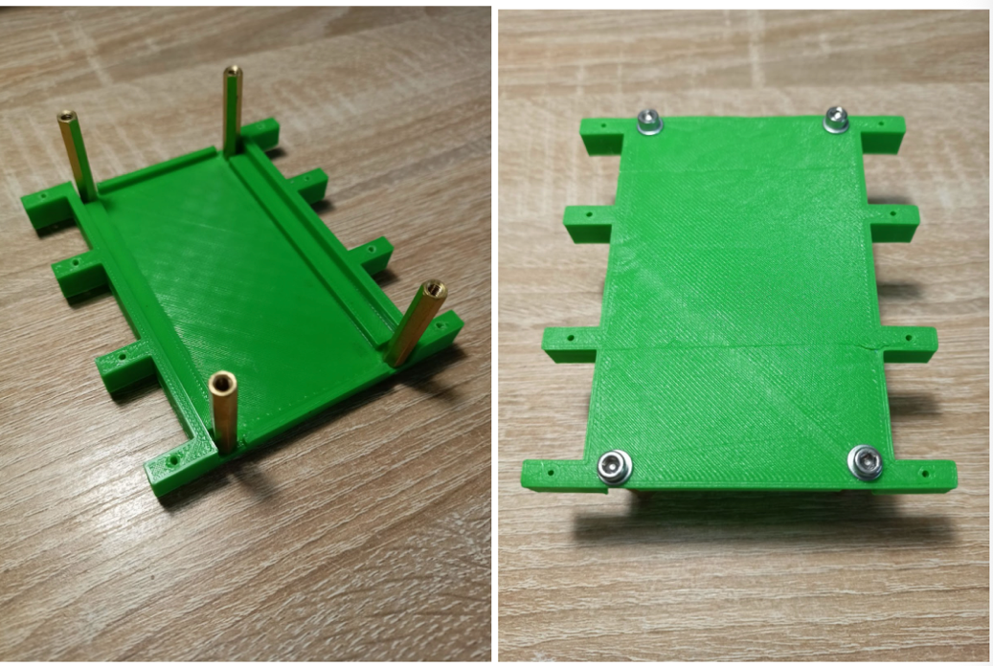

Before mounting the top plate on it, it is necessary to fix the expansion board using M3x10 screws and M3 nuts (fasten the board to two screws that are close to each other in the center of plate), since access to these screws will be difficult after full assembly. Do not forget about the M3 size washer on the plastic side! Similarly (using M2x8 screws, washers and M2 nuts) fix the DC-DC buck (step-down) converter.

The last step is to mount the plate to the racks. Insert M3x10 screws into the holes below the expansion board and M3x6 screws into the other two holes (under these screws place M3 washers). Then, insert the Arduino board into the expansion board.

Insert the shoulders of the robot into the corresponding grooves in the case and attach the claws to the servos. All servos should be fixed to the plastic parts using the self-tapping screws included in the kit.

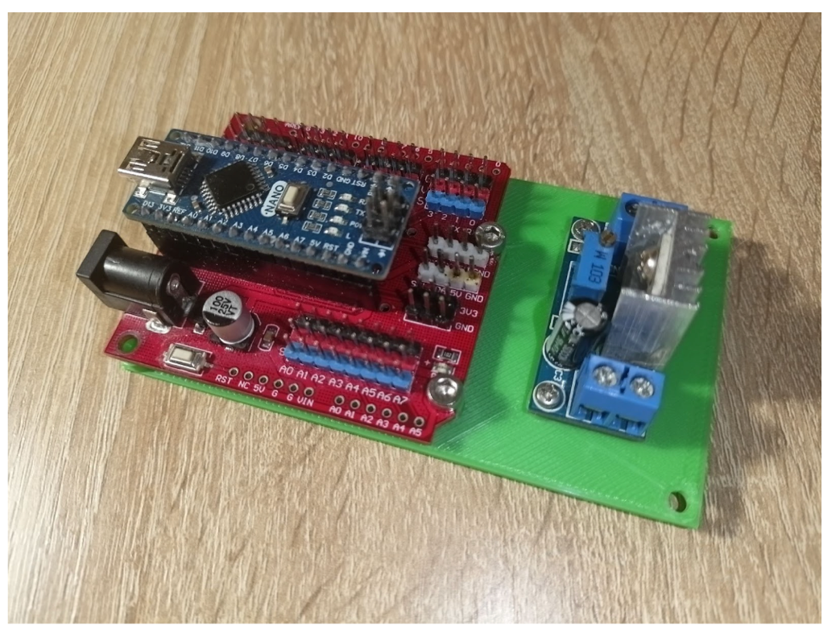

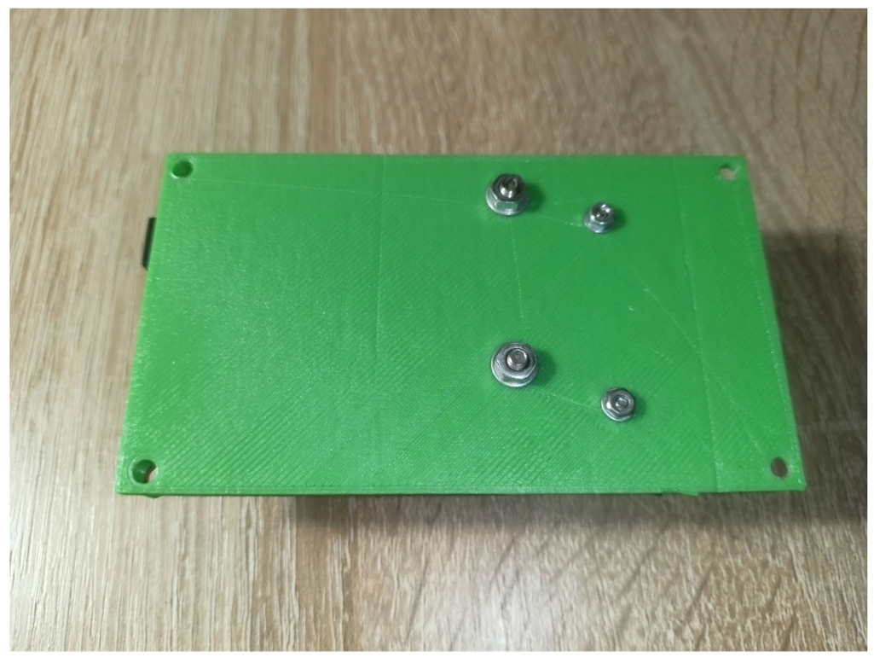

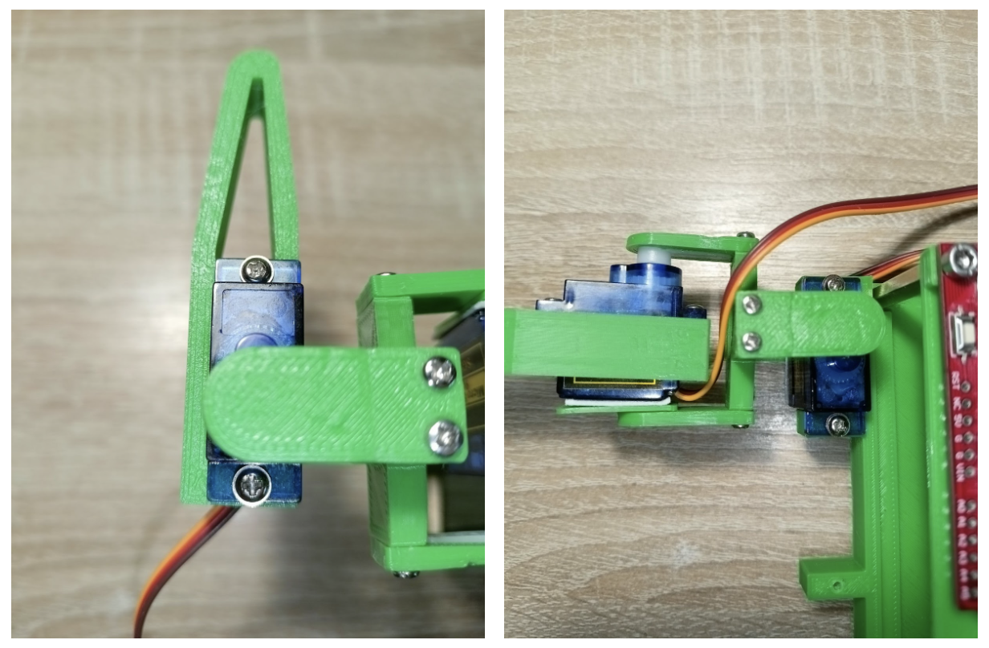

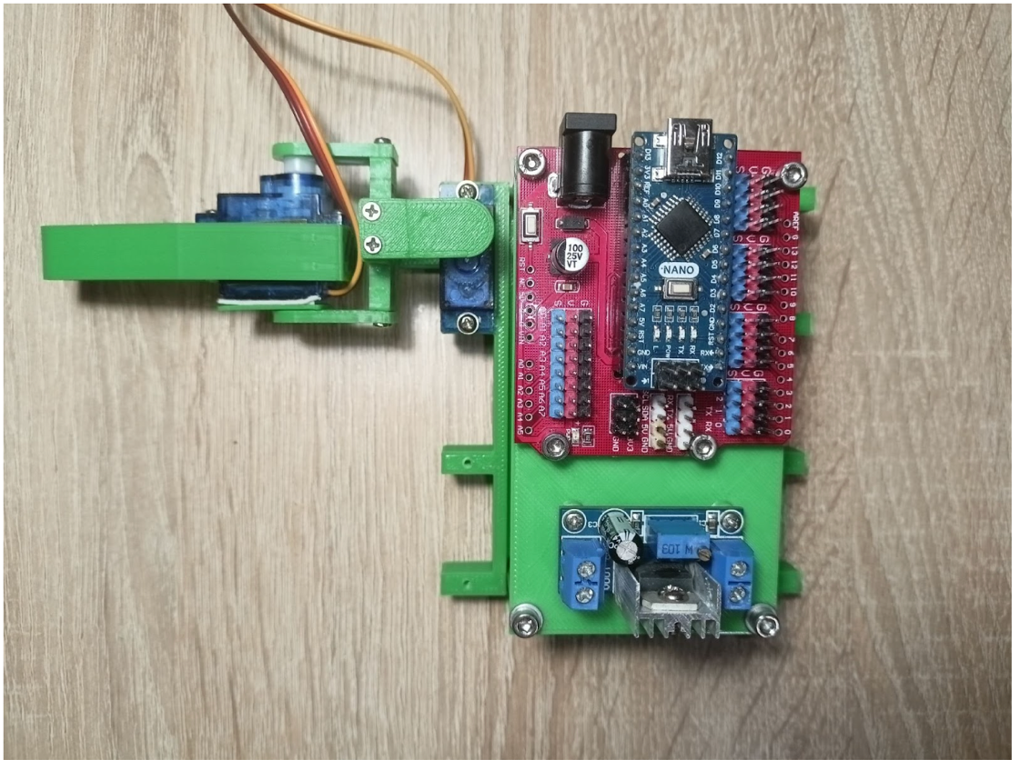

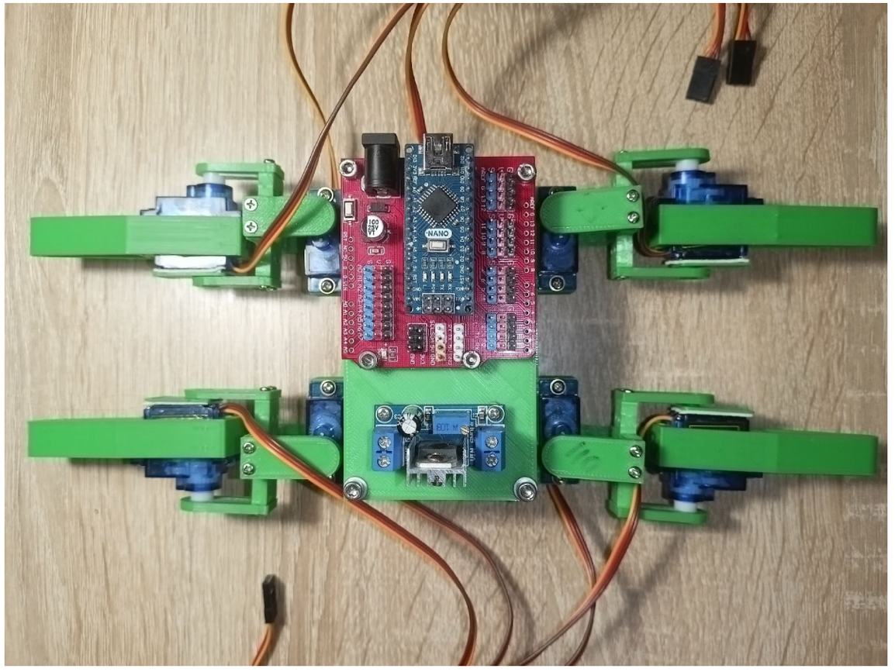

The selected model of the buck (step-down) converter has a convenient way of connecting wires - terminal blocks. After loosening the screws, insert each wire into its socket and tighten the screws back. Connecting the converter is carried out according to the scheme below.

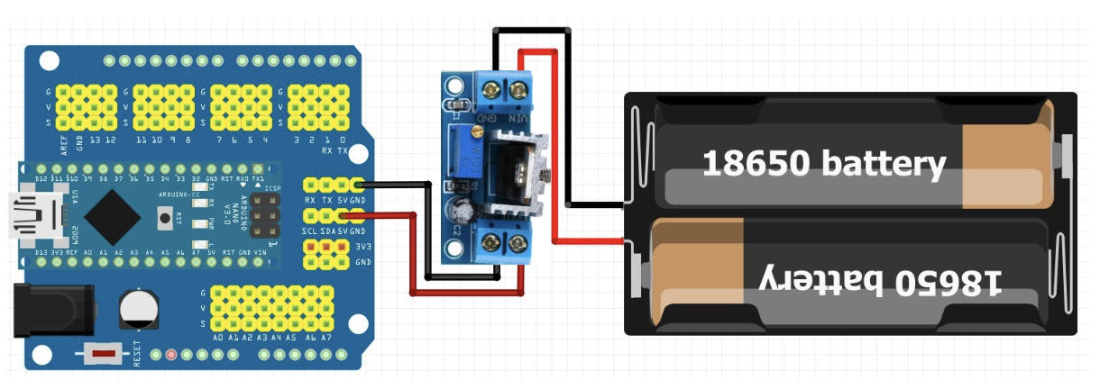

It is important to observe the polarity of the power supply (typically, red wire is plus and black is minus), as well as the correct order od connecting the input and output pairs od contacts (in our case, the wires from the battery compartment are connected to the pins VIN and GND (input of converter), and the wires going to the expansion board are connected to the pins VOUT and GND (output of converter)). After tightening the bolts, ensure the wires are securely held in the connector by gently tugging them. Now, place the battery compartment in the body (case) of the robot.

Shoulder servos will connect to odd ports, and claw servos to even ports. We count from the fourth pin. Servos are denoted clockwise. For the head of the robot take the edge to which the expansion board is closer. The buck converter will be located closer to the tail.

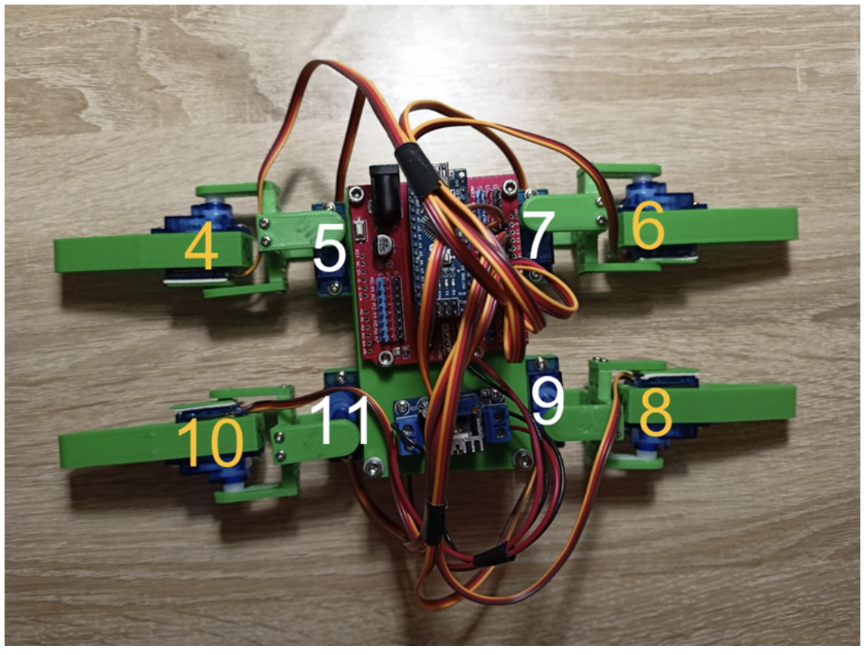

Calibration code will help us to calibrate. The program sets all servos in zero position when the board is turned on. We’ll see if there’s an imbalance in the leg structure, if the servo horns are properly set. If any leg is not perpendicular to the body (case), this must be corrected mechanically. It means pulling out of the support, putting it correctly on the servos and attaching it back in. A small inaccuracy in the angles of the servos for this robot is not allowed.